**Classifying Direct Marketing Campaigns using Naive Bayes**

Name: Amos Lipsys

Subject Coordinator: Ickjai Lee

Date: 3rd June 2017

Subject: CP3403 Data Mining

**ABSTRACT**

The main objective was to create a classification model of a Portuguese banking institution direct marketing scheme. This model could then be used to increase effectiveness of future marketing campaigns. Data mining techniques were used to achieve this goal. Naïve Bayes classification method was used to analyse the data to get a

* State main objectives. (What did you investigate? Why?)
* Describe methods. (What did you do?)
* Summarize the most important results. (What did you find out?)
* State major conclusions and significance. (What do your results mean? So what?)

Example Abstract. Abstract must be under 200 words and not include subheadings or citations. Example Abstract. Abstract must be under 200 words and not include subheadings or citations. Example Abstract. Abstract must be under 200 words and not include subheadings or citations. Example Abstract. Abstract must be under 200 words and not include subheadings or citations. Example Abstract. Abstract must be under 200 words and not include subheadings or citations. Example Abstract. Abstract must be under 200 words and not include subheadings or citations. Example Abstract. Abstract must be under 200 words and not include subheadings or citations. Example Abstract. Abstract must be under 200 words and not include subheadings or citations.

Please note: Abbreviations should be introduced at the first mention in the main text – no abbreviations lists. Suggested structure of main text (not enforced) is provided below.

**Introduction**

The Introduction section, of referenced text1 expands on the background of the work (some overlap with the Abstract is acceptable). The introduction should not include subheadings.

**Results**

Up to three levels of **subheading** are permitted. Subheadings should not be numbered.

**Subsection**

Example text under a subsection. Bulleted lists may be used where appropriate, e.g.

* First item
* Second item

***Third-level section***

Topical subheadings are allowed.

**Discussion**

The Discussion should be succinct and must not contain subheadings.

**Methods**

Topical subheadings are allowed. Authors must ensure that their Methods section includes adequate experimental and characterization data necessary for others in the field to reproduce their work.

**References**

**1.** Figueredo, A. J. & Wolf, P. S. A. Assortative pairing and life history strategy - a cross-cultural study. *Hum. Nat.* **20**, 317–330 (2009).

LaTeX formats citations and references automatically using the bibliography records in your .bib file, which you can edit via the project menu. Use the cite command for an inline citation, e.g.1.

**Acknowledgements (not compulsory)**

Acknowledgements should be brief, and should not include thanks to anonymous referees and editors, or effusive comments. Grant or contribution numbers may be acknowledged.

**Author contributions statement**

Must include all authors, identified by initials, for example: A.A. conceived the experiment(s), A.A. and B.A. conducted the experiment(s), C.A. and D.A. analysed the results. All authors reviewed the manuscript.

**Additional information**

To include, in this order: **Accession codes** (where applicable); **Competing financial interests** (mandatory statement).

The corresponding author is responsible for submitting a [competing financial interests statement](http://www.nature.com/srep/policies/index.html#competing) on behalf of all authors of the paper. This statement must be included in the submitted article file.

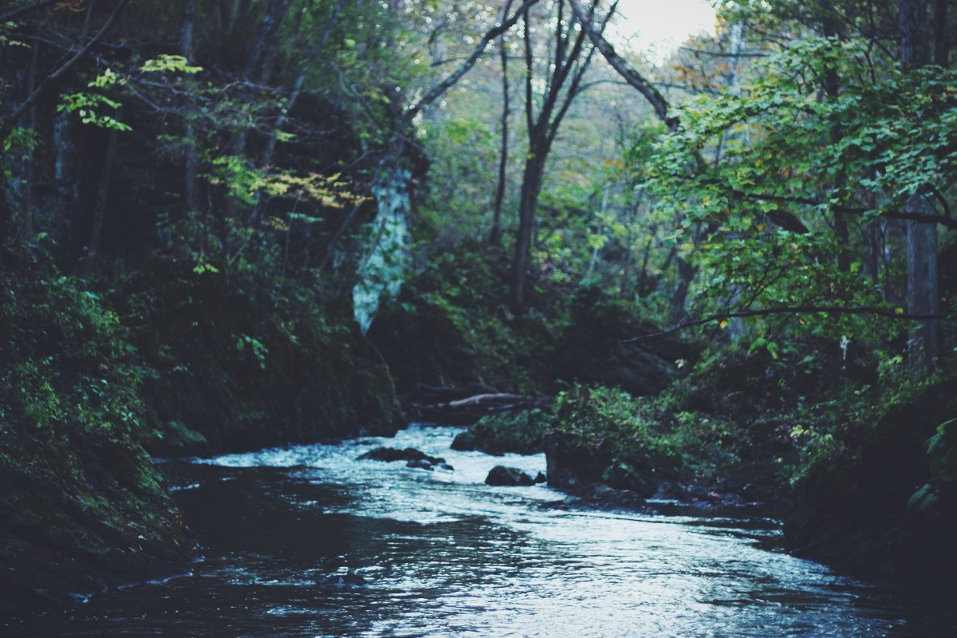

**Figure 1.** Legend (350 words max). Example legend text.

|  |  |  |
| --- | --- | --- |
| Condition | n | p |
| A | 5 | 0.1 |
| B | 10 | 0.01 |

**Table 1.** Legend (350 words max). Example legend text.

Figures and tables can be referenced in LaTeX using the ref command, e.g. Figure 1 and Table 1.

**2/**2

* + Introduction (1 page)
    - Brief background
  + Description on Dataset (1-2 pages)
    - Details about the dataset including how many instances, attributes etc
  + Preprocessing
    - Details about the preprocessing done for the dataset including cleaning, transformation etc
  + DM Area and DM Algorithm
    - Brief introduction into DM area & algorithm of your choice and provide justifications for the choice
  + Scenarios (Exploration of the Effect of k in k-means clustering)
    - Explanation on what you are going to do in your DM project
  + Results and Analysis
  + Conclusion
  + Reference